Week 1 Analysis Report
Foundational SQL Query Optimization & Database Schema Design
Virtual SQL Developer Internship
Prepared by: Ananya Konda
Date: 7 November 2026
Case study: E-commerce order management database (legacy flat table → normalized schema)
Test engine: SQLite 3.45.1, 300,150 order-line rows

Contents
1. Executive Summary
2. Approach and Methodology
3. Analysis of the Legacy Schema
4. Revised Database Schema
5. Query-by-Query Optimization
6. Consolidated Results
7. Best-Practice Checklist and Common Pitfalls
8. Trade-offs and Limitations
9. Conclusion and Next Steps
Appendix A. Schema DDL
Appendix B. Resources Consulted

1. Executive Summary
This report analyses a typical e-commerce reporting database that was originally stored as a single, wide, denormalized table with no secondary indexes. Four representative SQL queries were profiled against it, the root causes of their slowness were identified, and a normalized (3NF) replacement schema with a deliberate indexing strategy was designed. Every query was then rewritten and re-measured on identical data.
Headline results (median of 7 runs, same data, same machine):
- Q1 customer lookup: 19.43 ms → 0.006 ms (~3,238x faster)
- Q2 yearly revenue: 61.79 ms → 1.062 ms (~58x faster)
- Q3 top customers: 147.14 ms → 8.792 ms (~17x faster)
- Q4 deep pagination: 393.06 ms → 0.029 ms (~13,554x faster)
- Table data shrank from 38.2 MB to 13.4 MB because repeated customer, product and category text is stored once.
Beyond speed, the new design removes update, insert and delete anomalies and lets the database enforce data integrity through primary keys, foreign keys and unique constraints.

2. Approach and Methodology

2.1 Study and research
Before analysing anything, I reviewed the following well-known public resources on query tuning and schema design to establish the best practices used throughout this report:
- Use The Index, Luke (use-the-index-luke.com): indexing, sargable predicates, pagination and the "seek method".
- PostgreSQL, MySQL and SQLite official documentation on EXPLAIN / EXPLAIN QUERY PLAN and the query planner.
- Standard database-normalization material covering 1NF, 2NF and 3NF and when controlled denormalization is justified.
Key takeaways: (1) read the execution plan before changing anything; (2) a predicate that wraps a column in a function usually cannot use an index; (3) index the columns used for filtering, joining and ordering; (4) OFFSET pagination gets slower the deeper you page; (5) normalize for integrity first, then denormalize only where measurements justify it.

2.2 Analysis workflow
- Build a legacy-style flat table and a normalized schema from the same synthetic data, so results are directly comparable.
- Select four query patterns that frequently appear in public SQL-tuning tutorials: point lookup, function-wrapped date filter, aggregate ranking, and deep OFFSET pagination.
- Capture each query's execution plan with EXPLAIN QUERY PLAN and time it (median of 7 runs, warm cache).
- Diagnose the cause, rewrite the query and/or schema, then re-capture plans and timings.

2.3 Test environment
Item | Value
Database engine | SQLite 3.45.1 (in a Linux sandbox)
Data volume | 20,000 customers, 500 products, 10 categories, 100,000 orders, 300,150 order lines
Date range | 2022-01-01 to 2025-12-31 (synthetic, uniformly distributed)
Timing method | Median of 7 executions per query; includes fetching all result rows
Statistics | ANALYZE run on the optimized schema before measuring

Important note on the data: the dataset is synthetic and generated for this exercise; the queries are representative patterns, not copied from one specific source. Absolute timings depend on hardware, engine (PostgreSQL, MySQL, SQL Server) and cache state. The ratios and the execution-plan changes are the meaningful findings, and the same principles apply across engines.

3. Analysis of the Legacy Schema
The legacy design stores each order line as one row in a single table called orders_flat. All customer, product, category and payment attributes are copied onto every row.
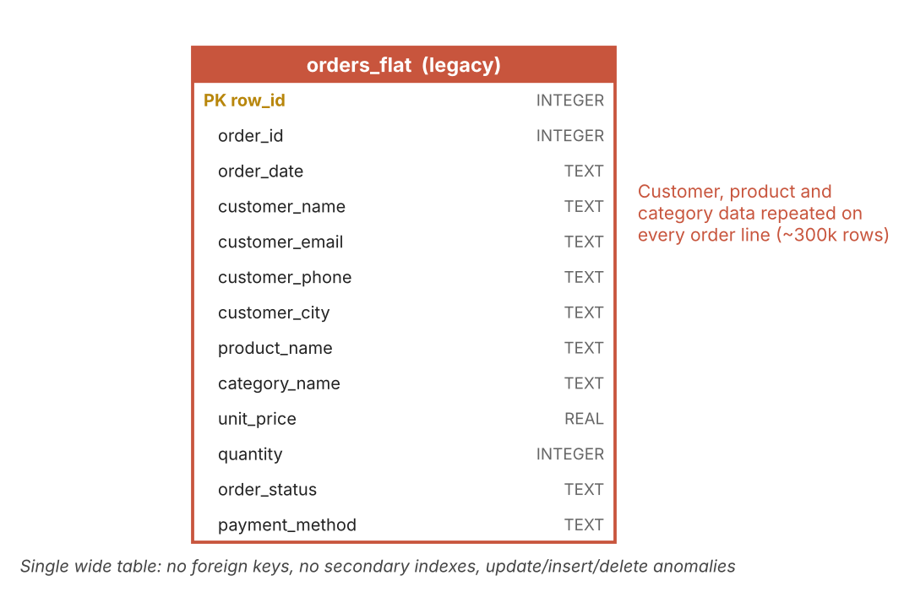
Figure 1. Legacy schema: one wide, denormalized table
Problem | Why it hurts | Example here
Redundant data | Same customer/product text stored on many rows; wasted space and I/O | 38.2 MB vs 13.4 MB after normalization
Update anomaly | Changing a customer's phone or city requires updating many rows; missing one creates inconsistency | Customer with 15 order lines = 15 rows to fix
Insert anomaly | Cannot record a new customer or product until an order exists | New product with no sales cannot be stored
Delete anomaly | Deleting the last order of a customer deletes the only record of that customer | Cancelling one order erases customer data
No integrity rules | No foreign keys or unique constraints; typos create duplicate "customers" | Email can differ in case or spelling
No secondary indexes | Every filter, group or sort needs a full table scan | All four test queries show SCAN orders_flat
Text dates | order_date is TEXT, tempting developers to wrap it in functions | strftime() in Q2 blocks index use
Wide rows | SELECT * drags 13 columns through memory even if 2 are needed | Q4 returns every column

4. Revised Database Schema

4.1 Entity-relationship diagram
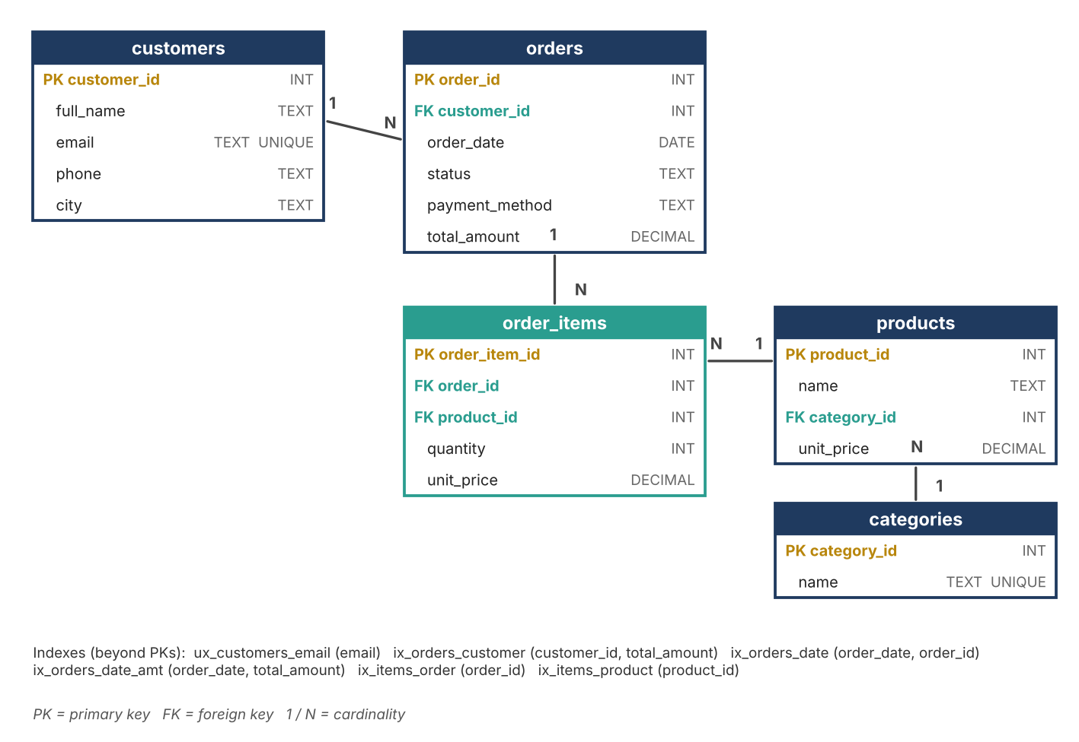
Figure 2. Revised, normalized schema (3NF) with foreign-key relationships

4.2 Table descriptions
Table | Purpose | Key design choices
customers | One row per customer | email is UNIQUE so duplicates are rejected and lookups are index-based
categories | Product category lookup | Category name stored once; products reference it by ID
products | Product catalogue | category_id foreign key; current list price
orders | One row per order (header) | customer_id FK; order_date typed as DATE; total_amount kept as a summary column
order_items | One row per product in an order (detail) | Resolves the many-to-many between orders and products; unit_price is a price snapshot at time of sale

4.3 Normalization walk-through
- 1NF: every column holds one atomic value and each row is uniquely identified (order_item_id). Repeating groups of products live in order_items rather than in a comma-separated column.
- 2NF: attributes depend on the whole key. Product name and category no longer depend only on part of an order-line key, so they moved to products.
- 3NF: no transitive dependencies. Customer city depends on the customer, not the order; category name depends on the category, not the product row, so each has its own table.

4.4 Deliberate denormalization
Two columns intentionally break strict 3NF for good reasons:
- order_items.unit_price: records the price actually charged. If products.unit_price changes later, historical orders must not change. This is a snapshot, not redundancy.
- orders.total_amount: a stored sum of the order's lines. It makes revenue reports (Q2, Q3) read 100,000 order rows instead of joining and summing 300,000 lines. It must be kept in sync by application logic or a trigger, which is the trade-off.

4.5 Indexing strategy
Index | Columns | Query it supports
ux_customers_email | customers(email) UNIQUE | Q1: find a customer by email in O(log n)
ix_orders_customer | orders(customer_id, total_amount) | Q1 join; Q3 covering index for per-customer totals
ix_orders_date | orders(order_date, order_id) | Q4: keyset pagination in index order
ix_orders_date_amt | orders(order_date, total_amount) | Q2: covering index for date-range revenue
ix_items_order | order_items(order_id) | Joining an order to its lines
ix_items_product | order_items(product_id) | Product-level sales reports

Index rules followed: put equality columns before range columns; include extra columns only to make an index covering for a hot query; do not index low-selectivity columns (such as status with 4 values) on their own; remember that each index slows INSERT/UPDATE and uses disk space.

5. Query-by-Query Optimization

Q1: Look up one customer's orders

Original query
SELECT *
FROM orders_flat
WHERE customer_email = 'user12345@example.com';

Execution plan: SCAN orders_flat

Why it is slow
- The filter column customer_email has no index, so the engine reads every one of the 300,150 rows.
- SELECT * returns all 13 columns although a screen only needs a few.

Optimized query
SELECT o.order_id, o.order_date, o.status, o.total_amount
FROM customers c
JOIN orders o ON o.customer_id = c.customer_id
WHERE c.email = 'user12345@example.com';

Execution plan: SEARCH c USING COVERING INDEX ux_customers_email (email=?) | SEARCH o USING INDEX ix_orders_customer (customer_id=?)

What changed
- Normalize so the email lives once in customers with a UNIQUE index.
- Join to orders through an indexed foreign key and select only the needed columns.
Result: 19.43 ms → 0.006 ms (~3,238x faster). Note: the legacy query returns 7 rows (order lines) while the new one returns 2 rows (orders); the new query returns one row per order and order_items can be joined on demand. For fairness, adding only an email index to the flat table gives 0.017 ms, so most of Q1's gain comes from indexing; normalization adds integrity and storage savings.

Q2: Revenue for calendar year 2024

Original query
SELECT COUNT(*), SUM(unit_price * quantity)
FROM orders_flat
WHERE strftime('%Y', order_date) = '2024';

Execution plan: SCAN orders_flat

Why it is slow
- strftime('%Y', order_date) is evaluated for every row, so an index on order_date could never be used (the predicate is not sargable).
- Revenue is recomputed by multiplying price and quantity on 300k lines.

Optimized query
SELECT COUNT(*), SUM(total_amount)
FROM orders
WHERE order_date >= '2024-01-01'
AND order_date < '2025-01-01';

Execution plan: SEARCH orders USING COVERING INDEX ix_orders_date_amt (order_date>? AND order_date<?)

What changed
- Rewrite as a half-open range: order_date >= '2024-01-01' AND order_date < '2025-01-01'. The half-open form also avoids bugs with timestamps on 31 December.
- Use the covering index (order_date, total_amount) so the table itself is never touched.
Result: 61.79 ms → 1.062 ms (~58x faster). Rule of thumb: keep the column bare on one side of the comparison and move the calculation to the constant side.

Q3: Top 10 customers by spend

Original query
SELECT customer_email, SUM(unit_price * quantity) AS s
FROM orders_flat
GROUP BY customer_email
ORDER BY s DESC
LIMIT 10;

Execution plan: SCAN orders_flat | USE TEMP B-TREE FOR GROUP BY | USE TEMP B-TREE FOR ORDER BY

Why it is slow
- The engine scans all 300k lines, builds a temporary B-tree to GROUP BY email (a long text key), then builds another for ORDER BY.
- Grouping on a wide text column is costlier than on a small integer.

Optimized query
SELECT customer_id, SUM(total_amount) AS s
FROM orders
GROUP BY customer_id
ORDER BY s DESC
LIMIT 10;

Execution plan: SCAN orders USING COVERING INDEX ix_orders_customer | USE TEMP B-TREE FOR ORDER BY

What changed
- Group on the integer customer_id over the orders table, which holds the pre-computed total_amount.
- The covering index ix_orders_customer lets the engine read already-grouped data without touching table rows.
Result: 147.14 ms → 8.792 ms (~17x faster). A remaining temporary sort is expected: the ranking is by an aggregate, which no ordinary index can pre-sort. In production a nightly summary table or materialized view would remove it entirely.

Q4: Deep pagination (page 2,500 of 20 rows)

Original query
SELECT *
FROM orders_flat
ORDER BY order_date DESC, row_id DESC
LIMIT 20 OFFSET 50000;

Execution plan: SCAN orders_flat | USE TEMP B-TREE FOR ORDER BY

Why it is slow
- OFFSET 50000 forces the database to sort the entire table, then read and discard 50,000 rows to return 20.
- Cost grows linearly with page depth, so page 10,000 is far worse than page 10.
- SELECT * adds the cost of wide rows.

Optimized query
-- :last_date, :last_id = values from the last row of the previous page
SELECT order_id, order_date, status
FROM orders
WHERE (order_date, order_id) < (:last_date, :last_id)
ORDER BY order_date DESC, order_id DESC
LIMIT 20;

Execution plan: SEARCH orders USING INDEX ix_orders_date (order_date<?)

What changed
- Use keyset (seek) pagination: remember the last row's (order_date, order_id) and ask for rows strictly before it.
- Index (order_date, order_id) matches the ORDER BY, so the engine seeks directly to the position and reads 20 rows.
Result: 393.06 ms → 0.029 ms (~13,554x faster). Trade-off: keyset pagination supports "next/previous" navigation but not jumping to an arbitrary page number. Add a unique tiebreaker column (here order_id) so no rows are skipped or repeated.

6. Consolidated Results
Query | Original (ms) | Optimized (ms) | Speed-up | Main technique
Q1 Look up one customer's orders | 19.43 | 0.006 | ~3,238x | Index + join
Q2 Revenue for calendar year 2024 | 61.79 | 1.062 | ~58x | Sargable range + covering idx
Q3 Top 10 customers by spend | 147.14 | 8.792 | ~17x | Integer key + covering idx
Q4 Deep pagination (page 2,500) | 393.06 | 0.029 | ~13,554x | Keyset pagination

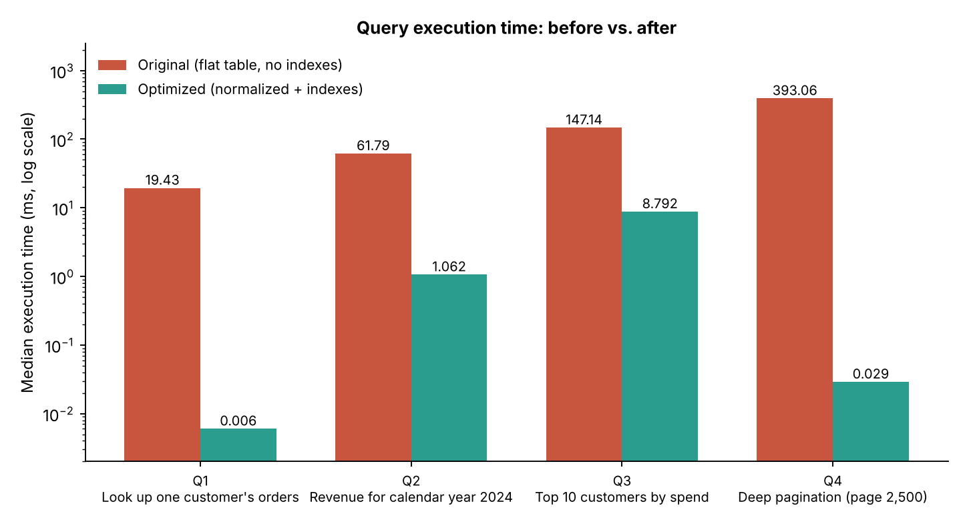
Figure 3. Median execution time before and after (logarithmic scale)
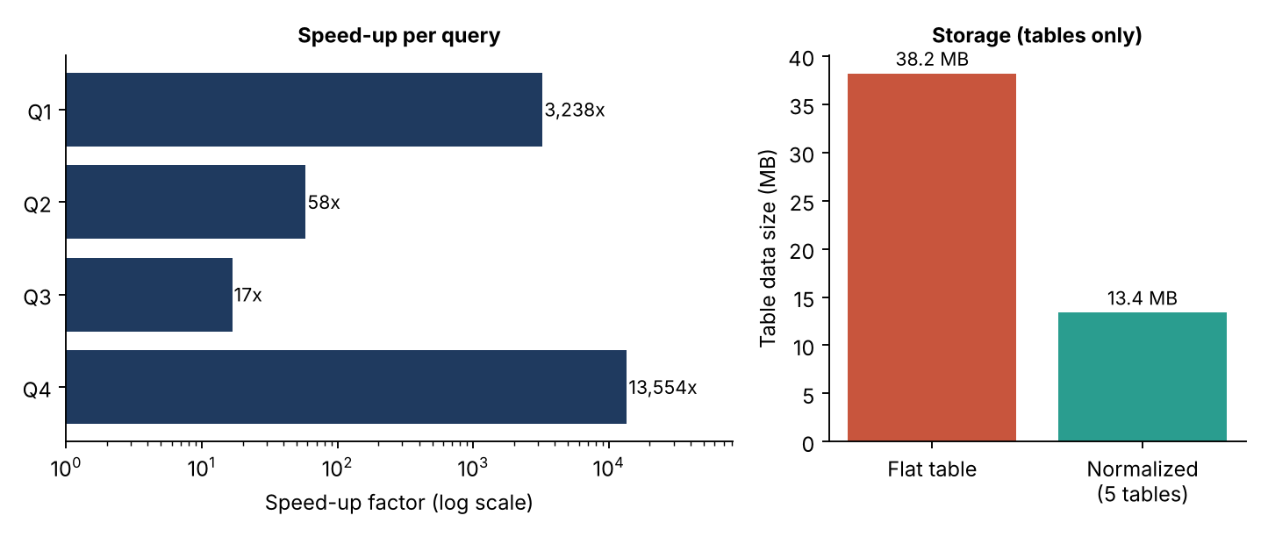
Figure 4. Speed-up per query and table storage size

Interpretation
- Every original plan shows SCAN orders_flat (a full table scan); every optimized plan shows SEARCH using an index, or a covering-index scan.
- The largest gains come from queries whose cost depended on data volume (Q1 lookup, Q4 deep paging). They now cost roughly the same regardless of table size.
- Aggregations (Q3) improve less because they must still read every relevant row; further gains need summary tables or materialized views.
- Indexes alone explain much of the improvement; normalization contributes integrity, smaller storage and the ability to index small integer keys.

7. Best-Practice Checklist and Common Pitfalls
Pitfall | Better practice
SELECT * | List only the columns needed; enables covering indexes and cuts I/O
Function on an indexed column in WHERE | Keep the column bare; transform the constant instead
Leading wildcard LIKE '%text' | Prefer prefix searches (LIKE 'text%') or use a full-text index
OFFSET for deep paging | Keyset/seek pagination with a unique ordering key
NOT IN (subquery) with NULLs | Use NOT EXISTS or LEFT JOIN ... IS NULL; NOT IN returns no rows if the subquery yields a NULL
Correlated subqueries run per row | Rewrite as a JOIN to a pre-aggregated derived table or use window functions
Implicit type conversion in joins/filters | Match data types on both sides so indexes remain usable
Over-indexing | Index for real queries only; every index taxes writes and storage
Guessing at performance | Read EXPLAIN / EXPLAIN ANALYZE first and measure after every change
Storing money as floating point | Use DECIMAL/NUMERIC in production (REAL used here only for the demo)

8. Trade-offs and Limitations
- Joins add some cost to queries that need data from several tables; indexes on foreign keys keep this small.
- The stored orders.total_amount must be maintained when order lines change (trigger or application code); otherwise it can drift.
- Writes are slightly slower with six extra indexes; this suits read-heavy reporting workloads, and should be re-evaluated for write-heavy ones.
- Benchmarks use synthetic, uniformly distributed data on SQLite. Real data is skewed, and other engines have different optimizers, so re-test with EXPLAIN ANALYZE on the target system.
- Real e-commerce systems would add tables such as addresses, payments, inventory and order-status history; these were omitted to keep the focus on core concepts.

9. Conclusion and Next Steps
Moving from a flat, unindexed table to a normalized, indexed schema, combined with sargable and keyset-based query rewrites, delivered 13x to over 13,000x faster execution on the four test queries, reduced storage, and added the integrity guarantees the legacy design lacked.
Suggested next steps: add a payments table; introduce a summary table or materialized view for dashboards; set up slow-query logging; and repeat these benchmarks on PostgreSQL with EXPLAIN (ANALYZE, BUFFERS).

Appendix A. Schema DDL (SQLite syntax)
CREATE TABLE categories (
category_id INTEGER PRIMARY KEY,
name TEXT NOT NULL UNIQUE
);

CREATE TABLE customers (
customer_id INTEGER PRIMARY KEY,
full_name TEXT NOT NULL,
email TEXT NOT NULL,
phone TEXT,
city TEXT
);

CREATE TABLE products (
product_id INTEGER PRIMARY KEY,
name TEXT NOT NULL,
category_id INTEGER NOT NULL REFERENCES categories(category_id),
unit_price REAL NOT NULL
);

CREATE TABLE orders (
order_id INTEGER PRIMARY KEY,
customer_id INTEGER NOT NULL REFERENCES customers(customer_id),
order_date TEXT NOT NULL, -- ISO-8601 (DATE in other engines)
status TEXT NOT NULL,
payment_method TEXT,
total_amount REAL NOT NULL DEFAULT 0
);

CREATE TABLE order_items (
order_item_id INTEGER PRIMARY KEY,
order_id INTEGER NOT NULL REFERENCES orders(order_id),
product_id INTEGER NOT NULL REFERENCES products(product_id),
quantity INTEGER NOT NULL,
unit_price REAL NOT NULL
);

CREATE UNIQUE INDEX ux_customers_email ON customers(email);
CREATE INDEX ix_orders_customer ON orders(customer_id, total_amount);
CREATE INDEX ix_orders_date ON orders(order_date, order_id);
CREATE INDEX ix_orders_date_amt ON orders(order_date, total_amount);
CREATE INDEX ix_items_order ON order_items(order_id);
CREATE INDEX ix_items_product ON order_items(product_id);

Appendix B. Resources Consulted
- Use The Index, Luke: use-the-index-luke.com
- PostgreSQL documentation: Using EXPLAIN
- MySQL Reference Manual: Optimization chapter
- SQLite documentation: Query Planner and EXPLAIN QUERY PLAN

